Downloaded from [here link for docker desktop for windows](https://desktop.docker.com/win/main/amd64/Docker%20Desktop%20Installer.exe?utm_source=docker&utm_medium=webreferral&utm_campaign=dd-smartbutton&utm_location=header).

Once download completes. Goto download and run installer as administrator or just double click on it.

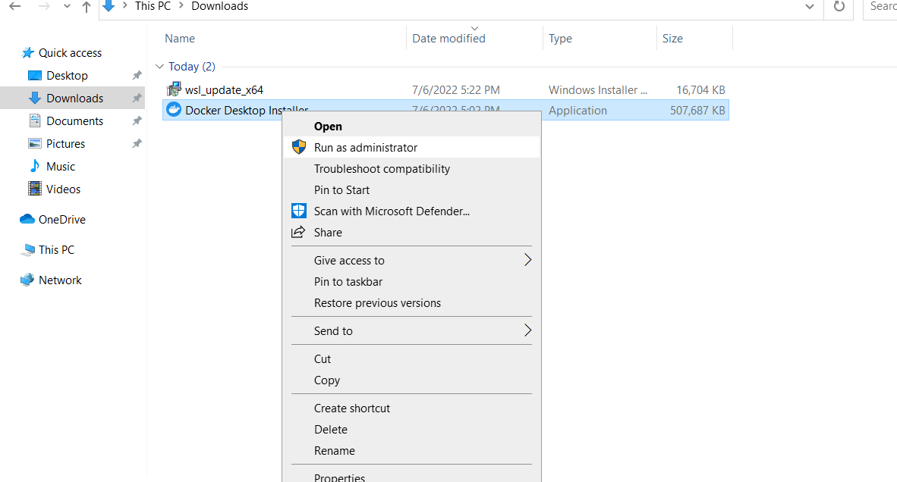

Click ok on below window.

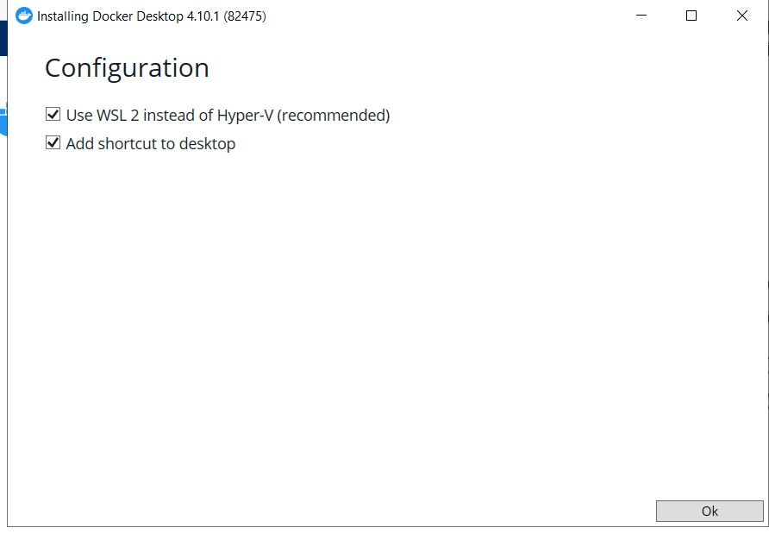

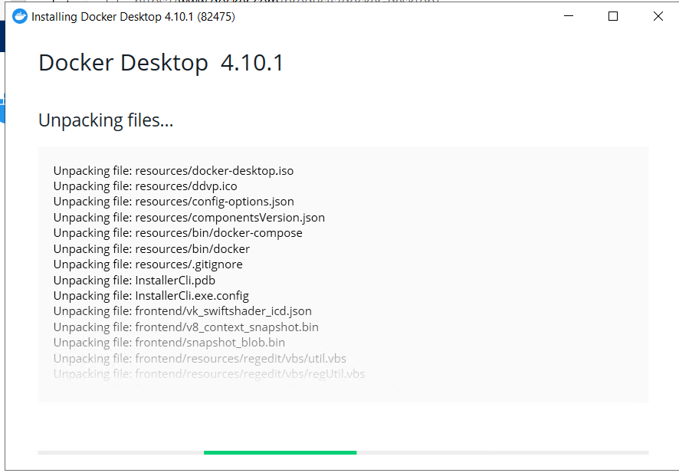

Click on close and restart. It will restart the VM.

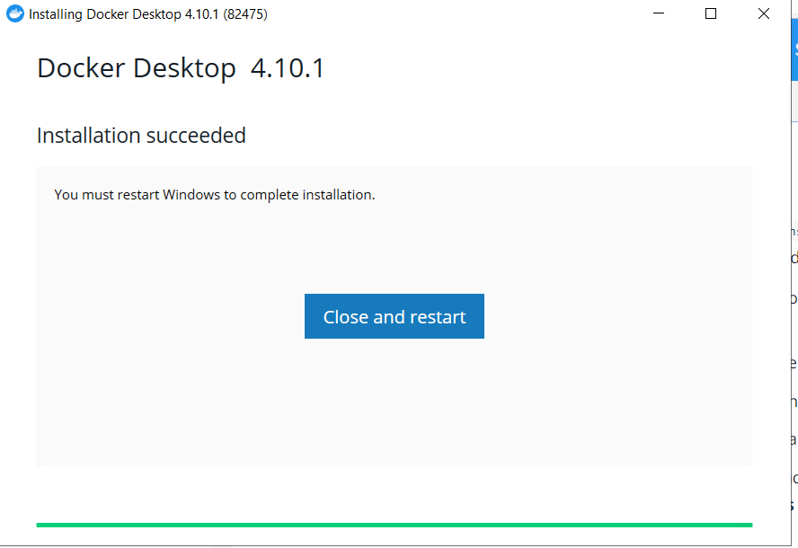

After VM restarted. Double click the docker desktop. It will open below windows. Check the I agree terms and click on accept.

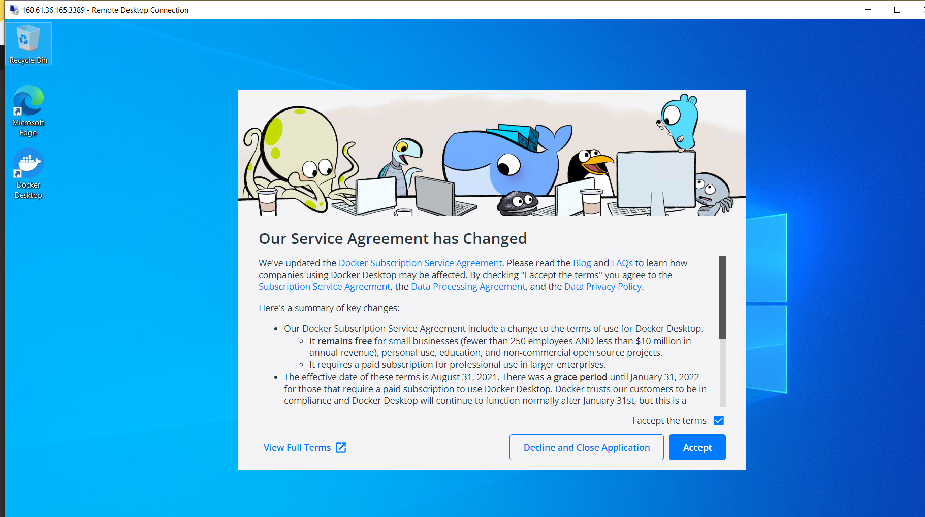

Then if WSL 2 is not properly installed below window open.click on the url displayed on window

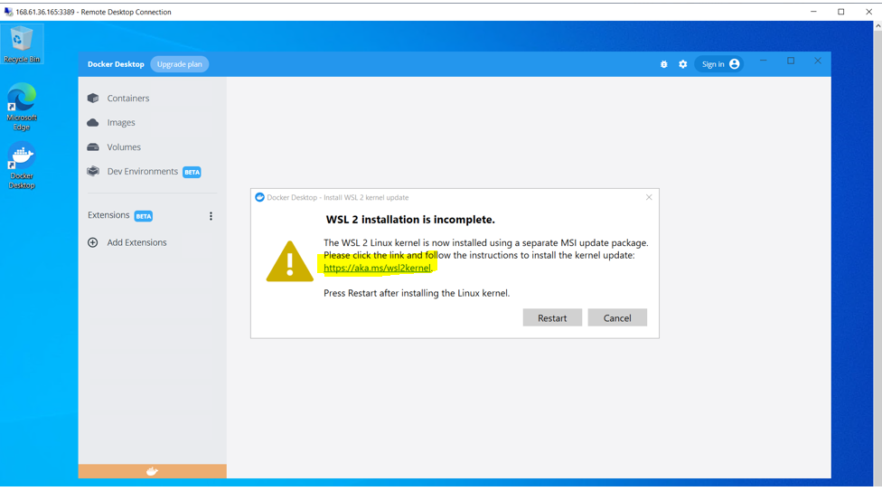

Once you click on the url, it will open web page. In that click the url in step4. After download run that installer.click next and next. Finally click on finish.

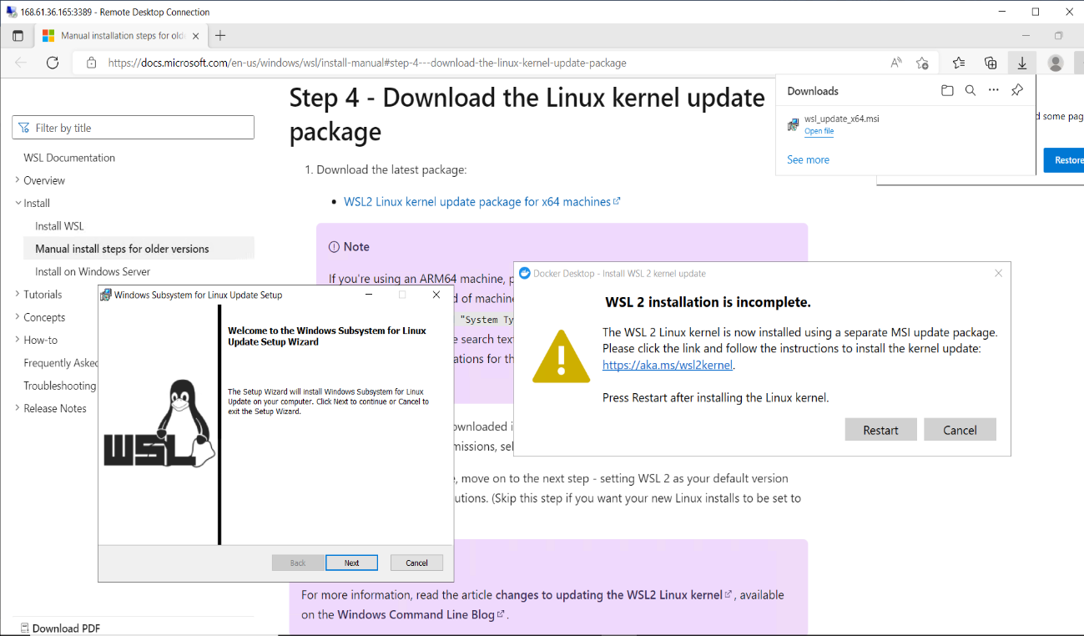

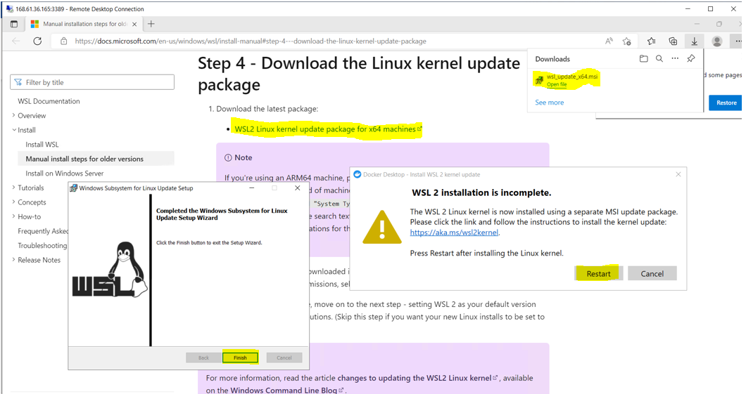

After click restart and wait for 2minutes to complete. Then double click on docker desktop icon.

Now if you observer docker desktop is starting and wait until docker desktop is ready.

Then it will display tutorial if you want see tutorial click on start or click on skip tutorial. I clicked on skip tutorial. Now docker desktop is ready to use.  
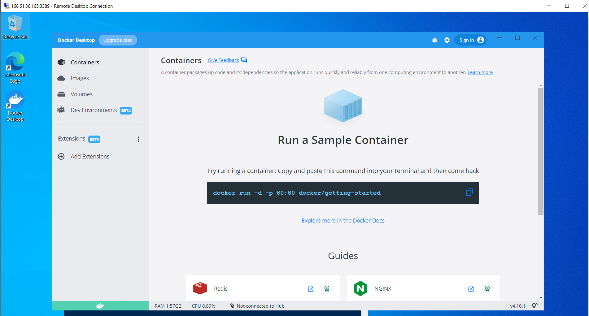

Check the docker version from powershell.

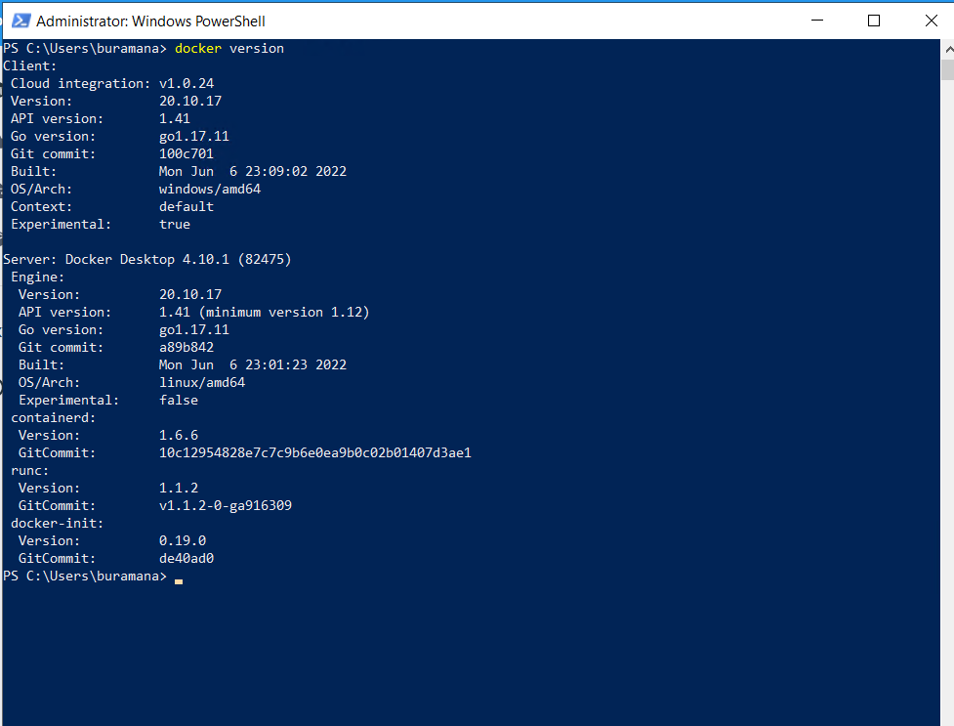

Now I want to add this machine as self-hosted agent in agent pool.

For that first I need to create PAT token.

Login to Azure develops and click on user icon on right side and select personal access tokens.

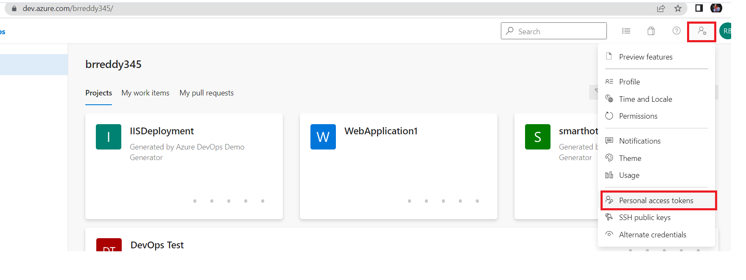

Then click on New token to create new token and enter the required details

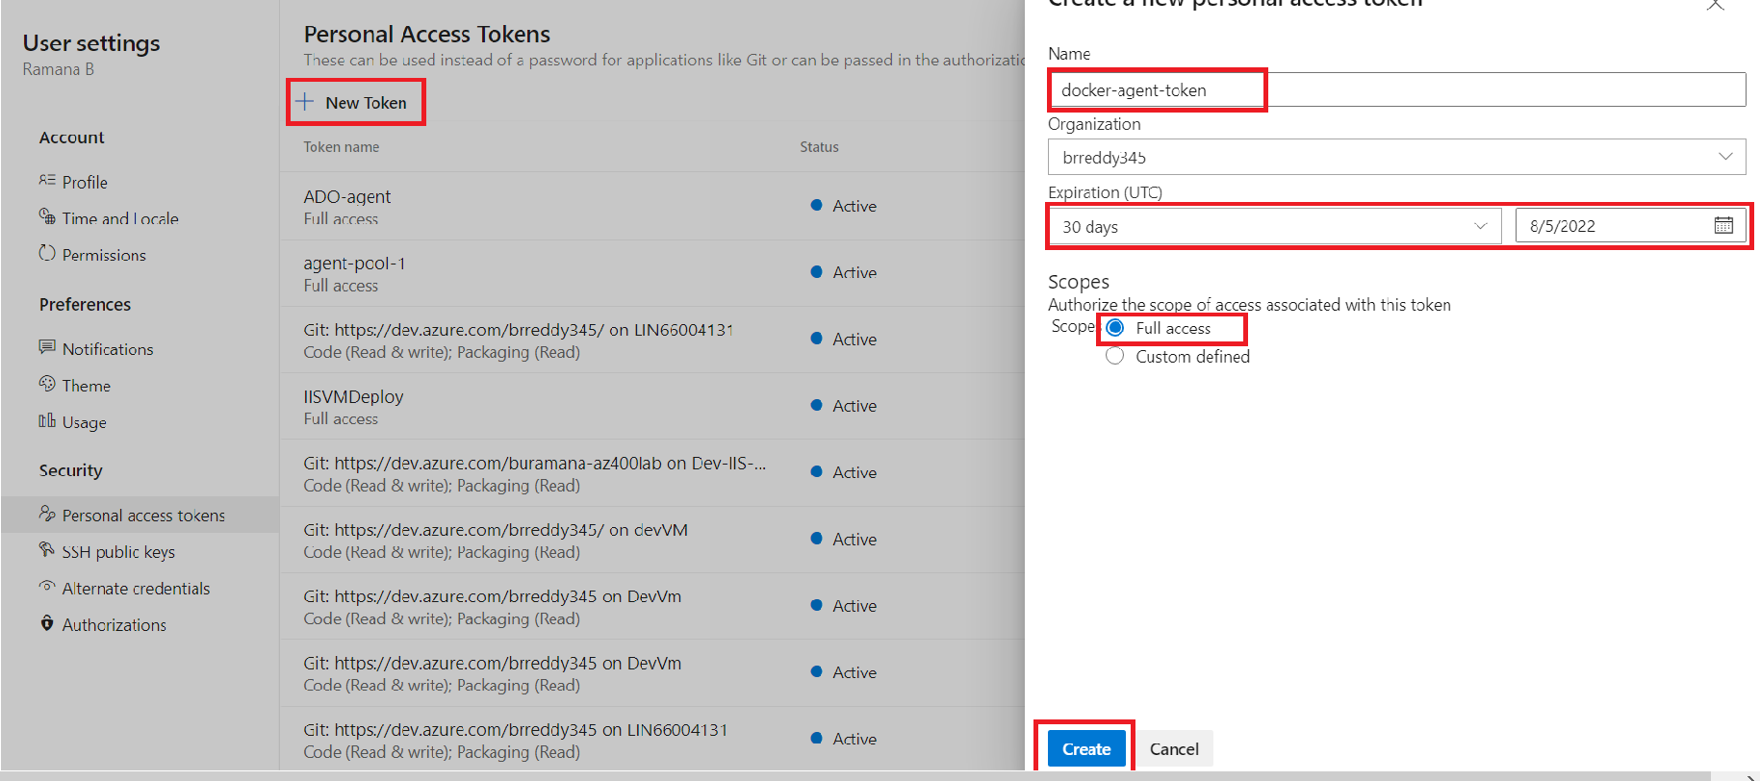

Copy the token and save it securely it required when agent installation and once closed it wont display again.

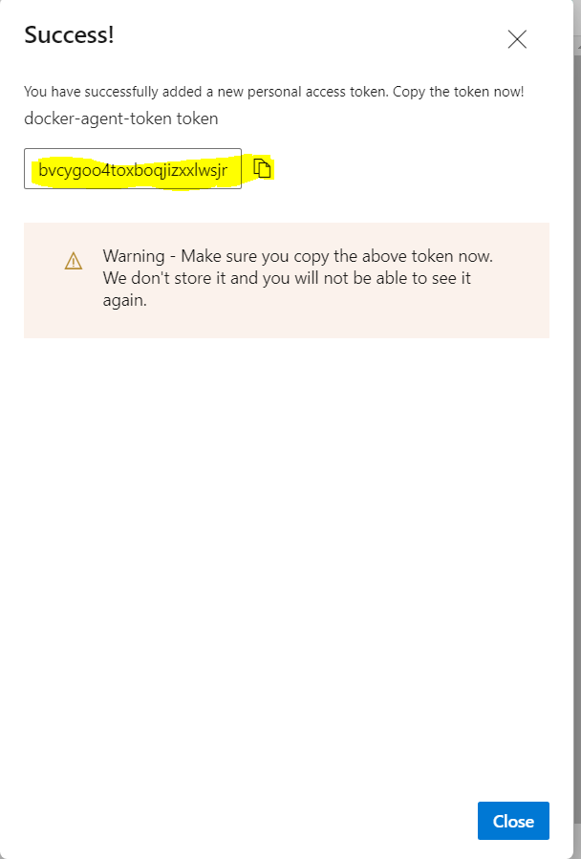

Click on close.

Now go to agent pools in organisation settings.

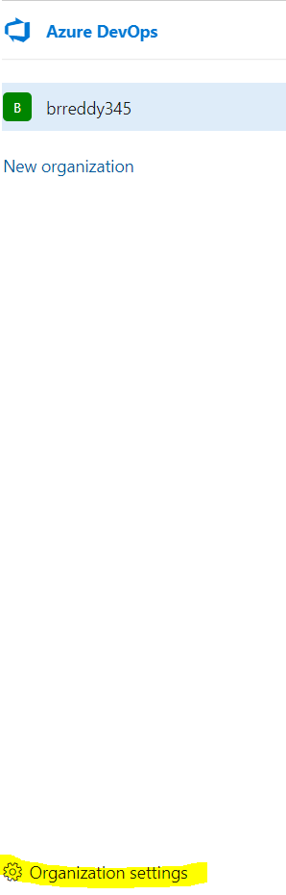

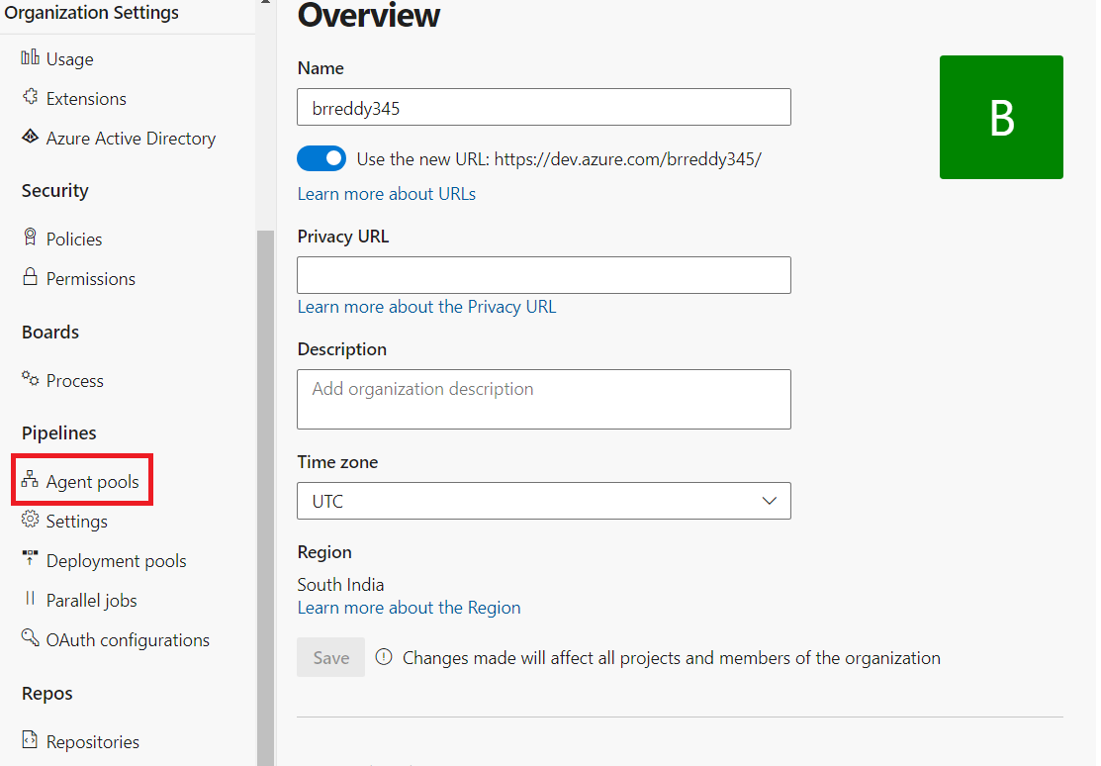

By default Azure pipelines and Default agent pools will be there. You can use them or you can add new pool by clicking on new pool. Here I am selecting Default pool to add my machine.

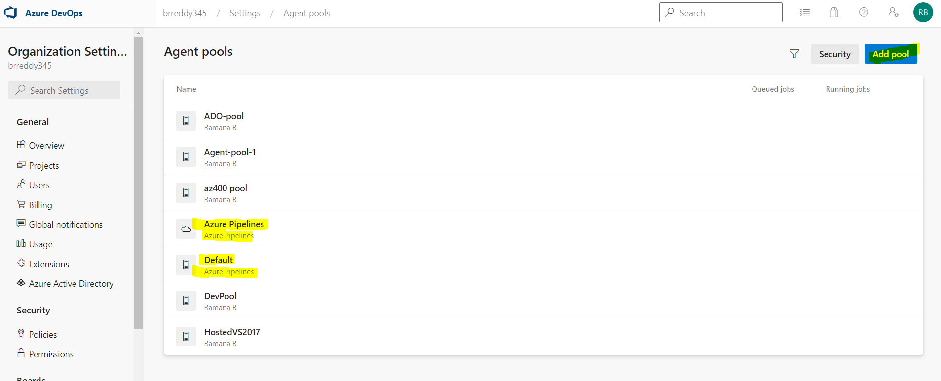

I select Default pool and to add agent click on New agent

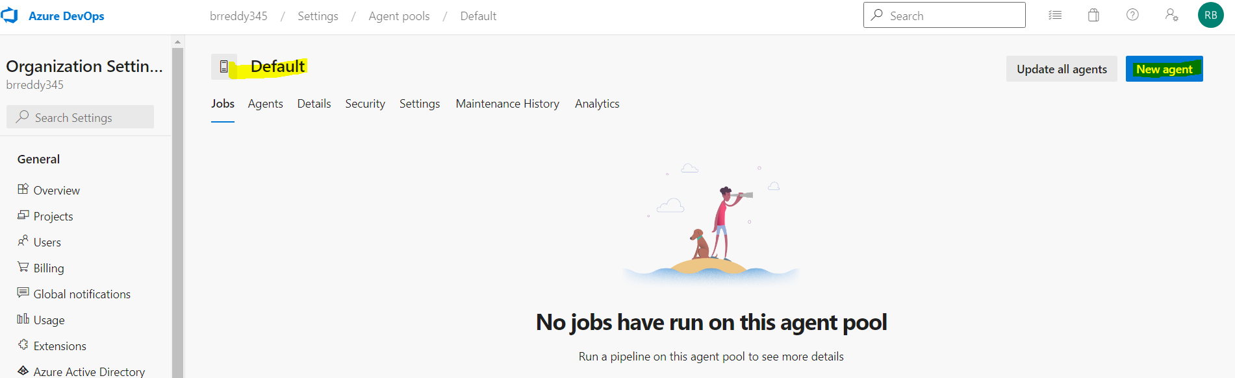

Now it will display the agent download and installation as per the VM OS. Here I am selecting window as my machine is windows.

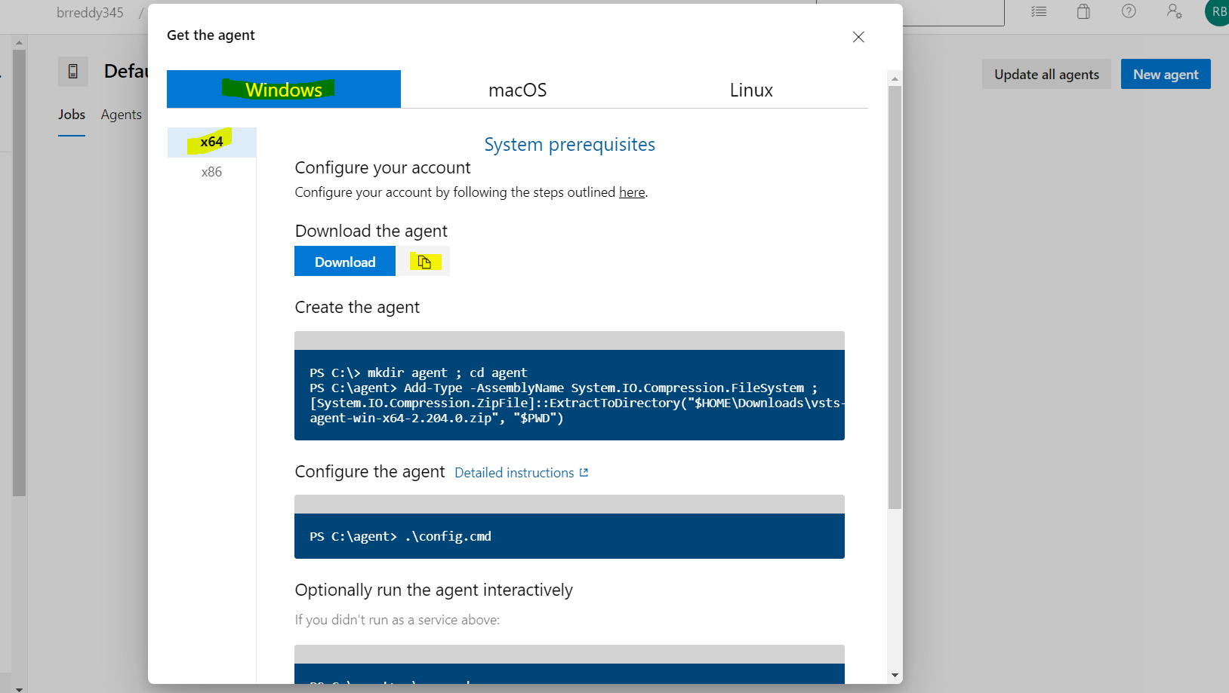

Click on copy symbol beside Download option to get the download url for agent. Open that url in VM and down load the agent.

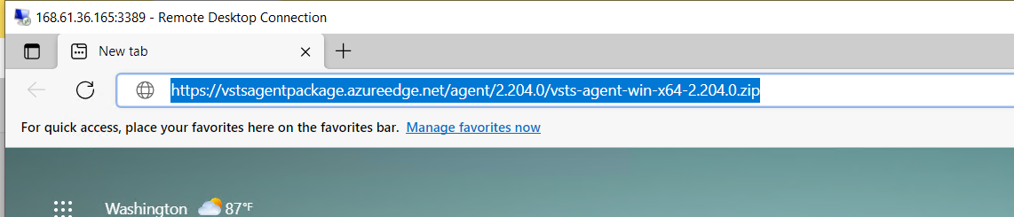

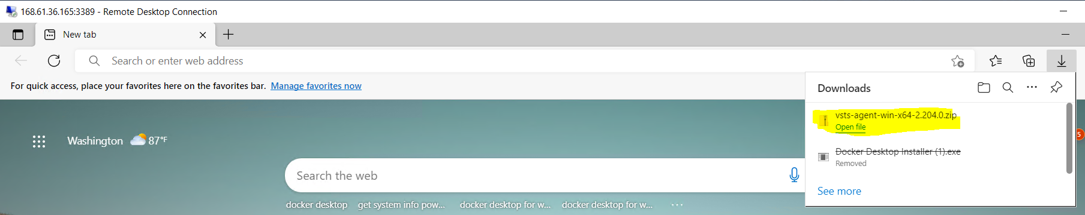agent download to Downloads folder

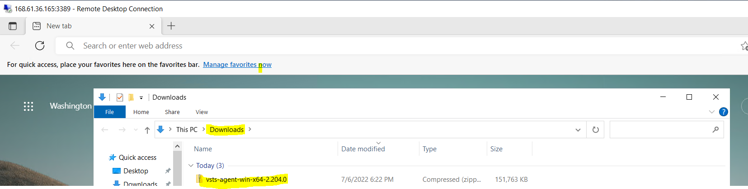

Now run the commands as displayed in Get the agent window.

Open powershell and go C:\ drive

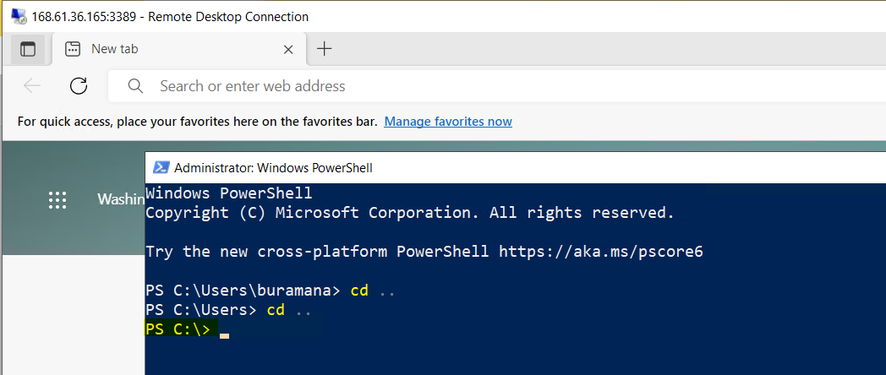

Now run the commands

mkdir agent ; cd agent

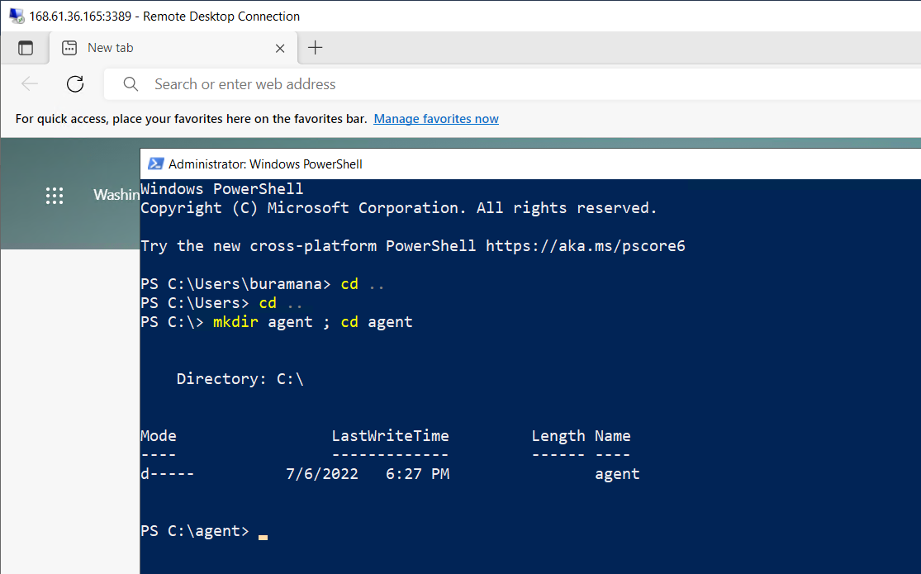

Then next command, it will unzip and copy that agent to agent folder which was created earlier.

Add-Type -AssemblyName System.IO.Compression.FileSystem ; [System.IO.Compression.ZipFile]::ExtractToDirectory("$HOME\Downloads\vsts-agent-win-x64-2.204.0.zip", "$PWD")

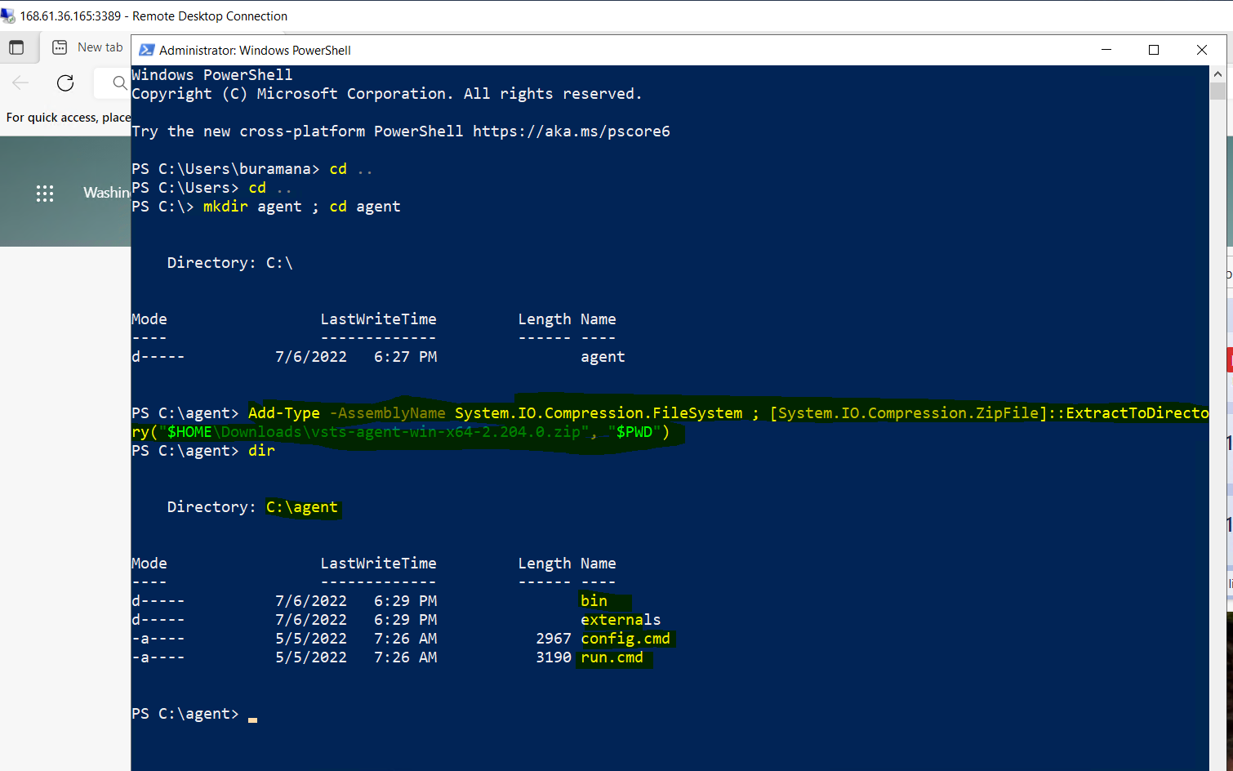

Now Configure the agent, type below command and hit enter

.\config.cmd

It will ask for the Server url. Server url means your azure devops organization url.

Here is my organization url :https://dev.azure.com/brreddy345/. Enter your organisation url and hit enter.

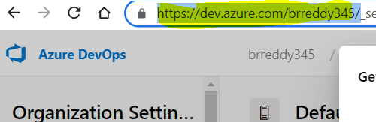

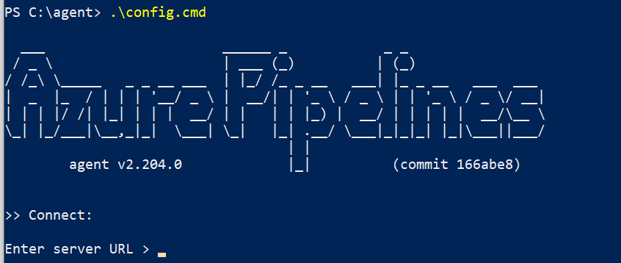

After adding url hit enter and then will ask for authentication type ,hit enter then copy paster the pat token which was created earlier. Then hit enter now, it will connect to azure devops and register it.

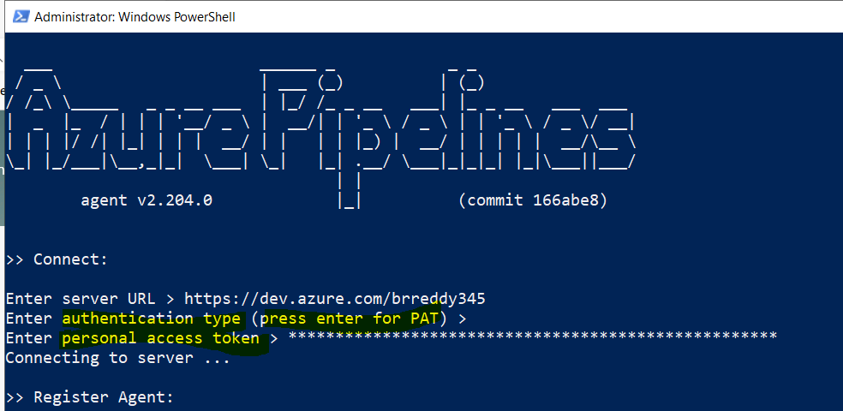

After this it will ask for agent pool name and agent name. here I am going with the default values. If you want use other than defaults you can enter there.

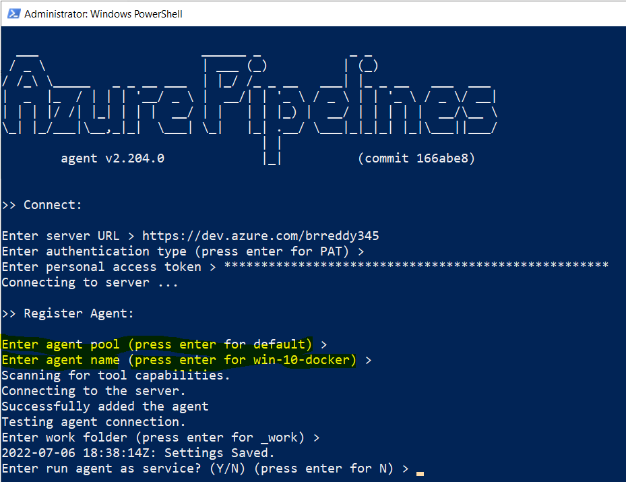

Here asking us run agent as serive- y/n I selected Y because I want to run it as an service and it will ask for the user name to run the service. I am going with default. Hit enter for default values.

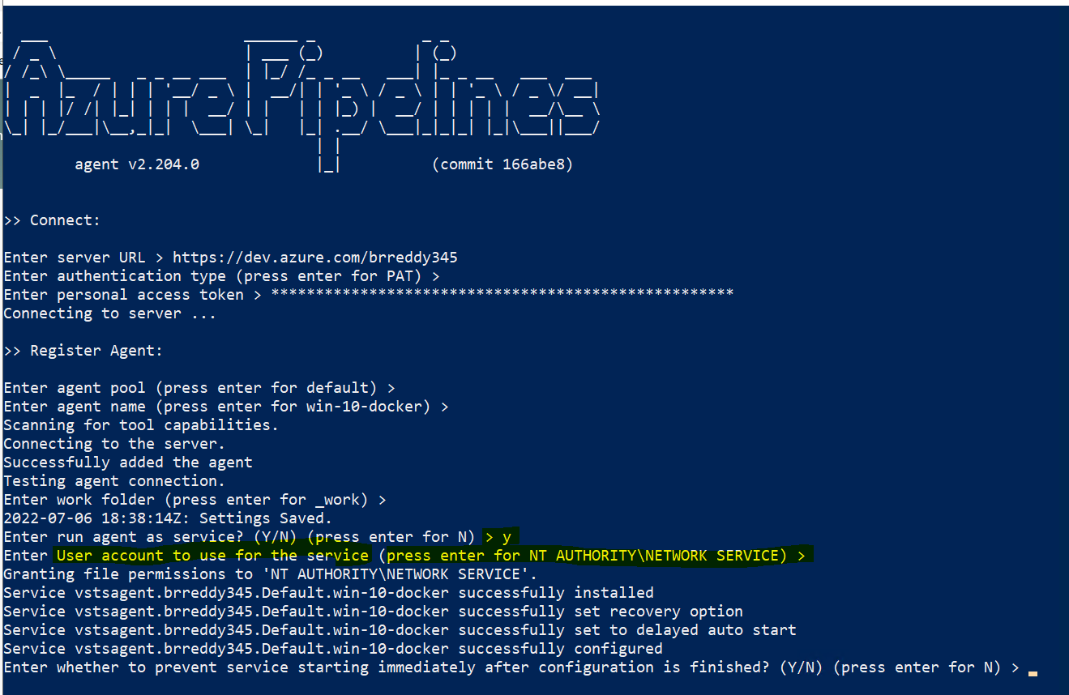

Then hit enter to start service immediately.

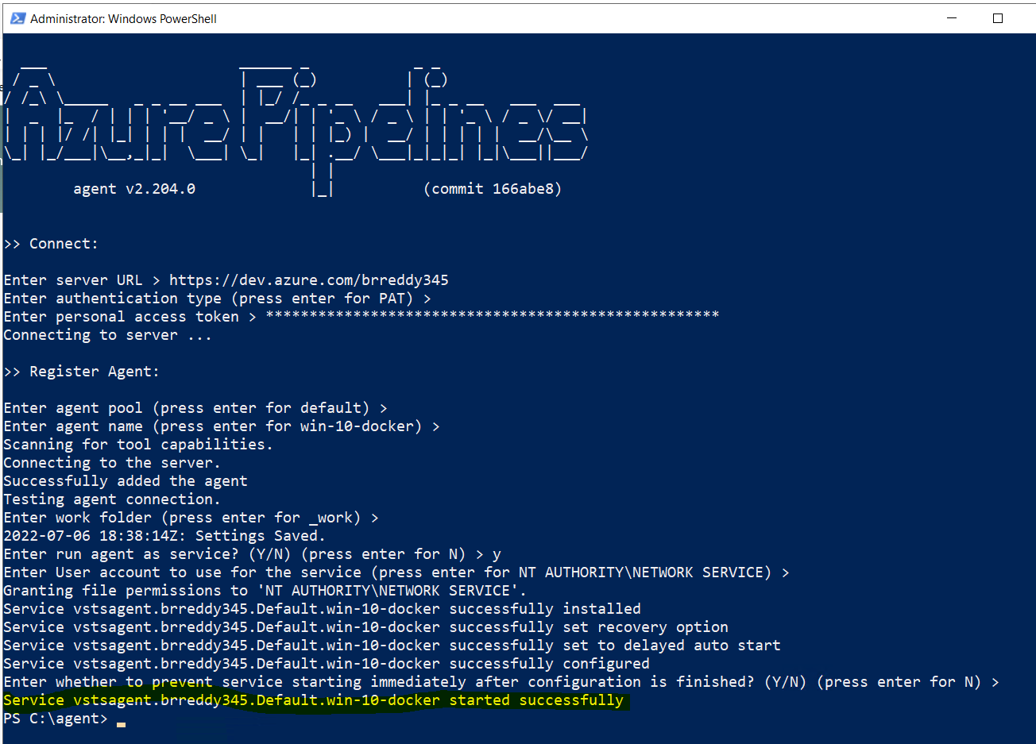

Now the agent service running.

To check open services and look for azurepipeline agent.

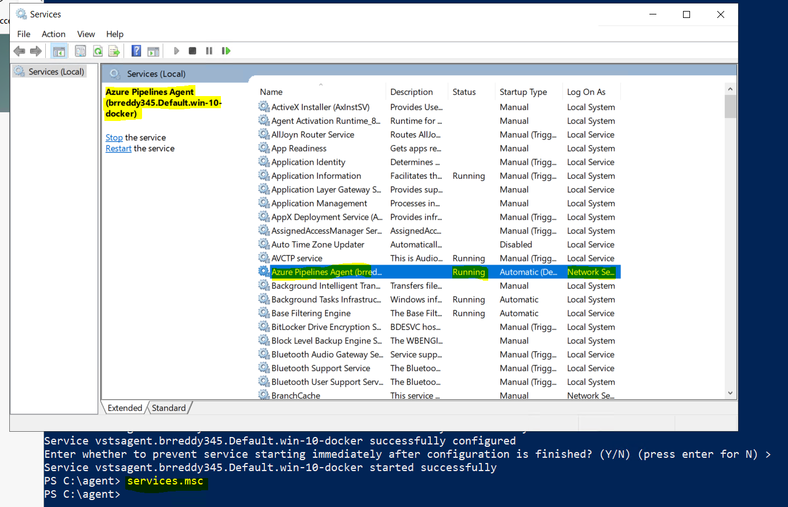

Now check in the default agent pool in azure devops

Close the get agent window and refresh the page. Goto default agent in agent pools of organization. Look for agent vm in agents

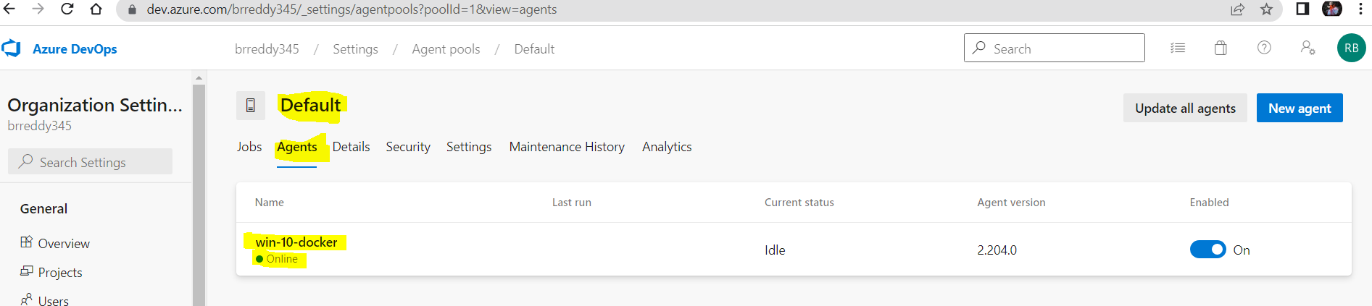

Now agent is ready to use in pipelines.